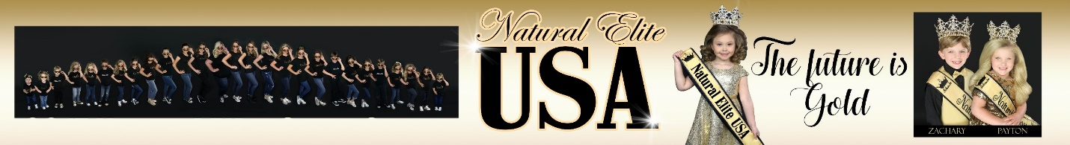
Secret Sister Questionnaire
Name: _____________________________________________________________
Initials: _____________(first, last, middle)
Address: ____________________________________________________________
Title: _______________________________________________________
Birthday:_______________Age:_______________
Favorite
Colors: ______________________________________________________________
Snacks: _____________________________________________________________
Drinks: ______________________________________________________________
Places to eat: _________________________________________________________
Candy/candy bars: _____________________________________________________
Bath and body scents: ___________________________________________________
Movies/TV Shows: _____________________________________________________
Shirt Sizes: _________ Shoe Sizes:______________
Hobbies: ______________________________________________________________________________________________________________________________________
If you received gift cards where would you like them from?
1._____________2. ______________3. __________
Where are your favorite places to shop: _______________________________________________?
Sports Teams: ______________________________
Any additional you would like to add:______________________________________________________________________________________________________________________________________________________________________________________________________

