Natural Elite Presents…
Miss Davidson County
Natural Pageant
Saturday, August 25, 2018
Denton Wesleyan Church
16345 NC-109
Denton, NC 27239

Pageant Starts at 1pm
Registration at 11am – Doors Open at 10:30am
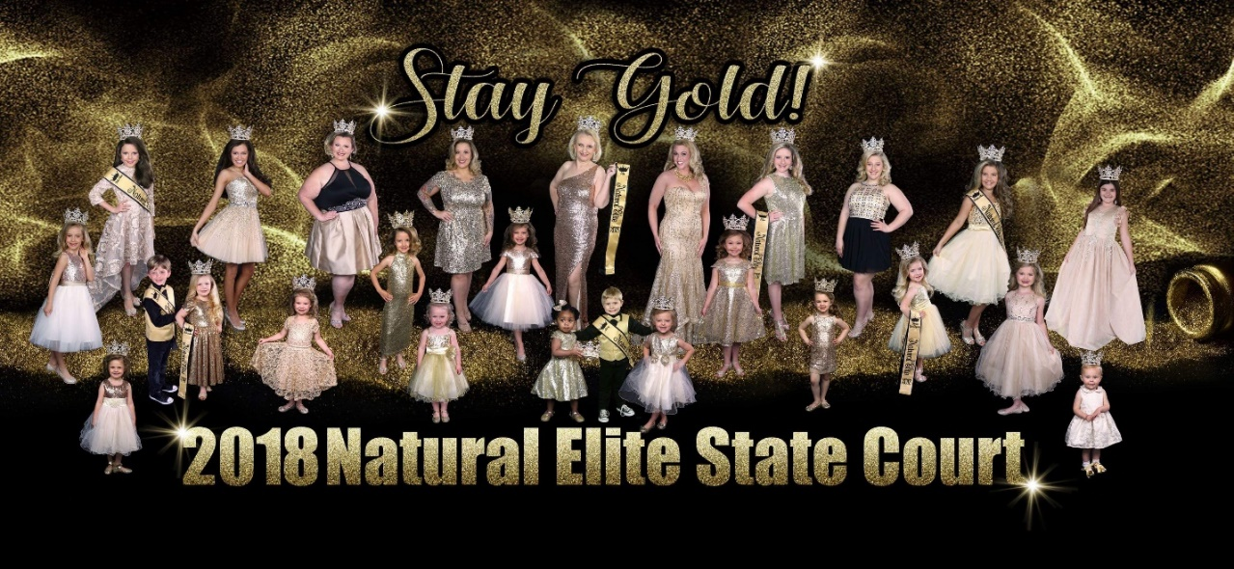

Age Divisions

Baby Miss - 0-18 months Wee Miss - 19-35 months
Tiny Miss - 3-4 years Young Miss - 5-6
Little Miss – 7-9 years Pre-Teen Miss – 10-12 years
Junior Miss - 13-15 years Teen – 16-18 years
Miss – 19-25 unmarried Ms. - 26 + unmarried
Mrs. - 21+ married Boys – All ages

Overall Titles
Mini Supreme 0-6 years
Grand Supreme – 7 years & up

Beauty: Mandatory (All Ages)
Contestant will be judged on their natural beauty, not the actual dress/outfit itself. Beauty wear may be Sunday best, holiday, portrait wear, or party dress as long as it is age appropriate. Overall judging will be based on stage projection of personality, beauty, poise and age appropriate grooming (fit, hair, makeup, and accessories). Makeup is allowed but should look natural! No props. *We reserve the right to combine age groups with only 1 entry. Division I Girls ages 0-6 should wear a short Sunday best dress. Division II Girls ages 7 and up, should wear a tea length or long dress. Shoes should coordinate with dress. Hair & Make up should be nicely styled and age appropriate.
No pageant cupcakes dresses allowed and rhinestones (if any) should be very limited on attire.

Most Photogenic (Optional All Ages)
Photogenic (can be head shot or full body shot) 8×10 print in color or b&w. Photo will be judged based on projection, clarity, appeal, hair, makeup, grooming and age appropriateness. Light retouching is allowed but must be natural - Photos should not be "glitzed." All photos should be turned in at registration in a clear cover to preserve print or they will not be accepted. Please label the back of photo with name and age division in upper left corner. We have professional hard cover jackets for $2 each at registration. Additional photo entries are $5 each and you can enter up to 2 additional for a total of 3 photos. They will be labeled A, B, C and judges will choose the one they like the most and score that photo only. Photos will be returned at the end of the pageant.

All winners will receive a crown, trophy, embroidered sash and discounts off of state fees.

Natural Elite: Registration Form
Pageant you are entering:______________________________________

CONTACT INFORMATION:

Contestant Name ___________________________________________________________________

Name of Contact for Pageant Updates___________________________________________________

Address__________________________________________________________________________

City____________________________State________ Zip_____________Phone ____________

Email____________________________________________________________________________

Contestant’s Date of Birth: _______________

EMCEE INFORMATION:

Pageant Participants Full Name:_______________________________________________________

Age (as of date of pageant)_____________ City of residence: ______________________

Sponsored By: _____________________________________________________________________

Eye Color___________________ Hair Color_____________________

School ____________________________________________________Grade___________

Siblings:__________________________________________________________________________

Special Accomplishments or Awards___________________________________________________

_________________________________________________________________________________

Hobbies/Special Interests_____________________________________________________________

_________________________________________________________________________________

Pets_____________________________

Favorite Food__________________________ Favorite Color_______________________________

Future Ambition: _________________________________________________________________________________

_________________________________________________________________________________

As the parent/guardian of ___________________________________________________, a participant in the Natural Elite pageant, I do hereby agree to abide by the rules and regulations, directives and provisions for contestants as set forth in the official rules and regulations. I agree to hold Natural Elite, its directors, staff members, and venue and its managers harmless of any damages or liabilities due to theft, accident or injury during or resulting from my child’s participation in the pageant. I accept the responsibility for the regulations of hours and personal activities of the contestant. I also affirm that all of the enclosed forms are true to the best of my knowledge and belief, including name, birthday, city and state of residence. I understand any false or misleading statements will be sufficient reason for dismissal from the pageant system. I further agree that if my child is selected winner or is captured on tape in any activity during the pageant, he/she will be allowed to appear online or in future publications of the pageant. I further agree that my child may appear in any website, brochure, or publication in the future without compensation after said pageant. Any contestant or winner caught in any unsportsmanlike conversations, or unruly acts of temper will be warned or the consequences of being dismissed from the pageant system. There will be no second chance if anyone is caught deliberately causing harm, either physical or verbal, and will be automatically dismissed from any future events of Natural Elite. We reserve the right to combine or cancel age groups based on number entered per group. I/my understand that pageant fees are non-refundable unless the pageant is cancelled. If non-refundable fee is not properly paid by the contestant or legal guardian of the contestant, I understand that legal procedures will follow immediately at the expense of the parent/guardian or contestant herself if of legal age.
________________________________________Signed on the ______day of ___________, 20____.

Email forms to Naturalelitenc@yahoo.com or
mail to Shea Walter, PO Box 512, Troy, NC 27371

Contestants Application and Fees

Mandatory Fee (Beauty Only) $50.00 _____

Optional Fees
Photogenic ~All Divisions $15.00______

Additional photos ~All Divisions $ 5.00______
$5.00 each if entering more than one

Total________
Or choose to be all in for best value!

OVERALL MINI & GRANDE SUPREME PACKAGE (INCLUDES BEAUTY & 1 PHOTO).
$65.00 ______

**Early Bird entries received and paid in full by August 10, 2018 may deduct $15
Forms of payments accepted:
- Paypal to naturalelitenc@yahoo.com as “friends & family” (plus $5 processing fee)
- Checks/Money order made payable to Natural Elite
- Request an invoice to pay by credit or debit (4% processing fee)

Please let us know if you have any questions at all!

Your NC State Director,
Shea Walter
910-975-2981
naturalelitenc@yahoo.com

